|  |  |
| --- | --- |
| Critical Information Summary | |
| Student Name | Huy Le Khanh TRAN |
| SID | 216410423 |
| Mark Aimed For (%) | 78% |

### Criteria: Towers and Bullets [Distinction]

* The tower can automatically determine seek to the target.
* Add feature for the towers, so they can upgrade and sell.
* Add animation for the towers to make more attractive and smoother.
* Support 2 different turrets (Mage Turret and Cannon Turret) to make the game more vivid.
* Corresponding to each tower are different types of bullets.
* Create effect for building the turret.
* Create effect for bullet when it hits the enemies.

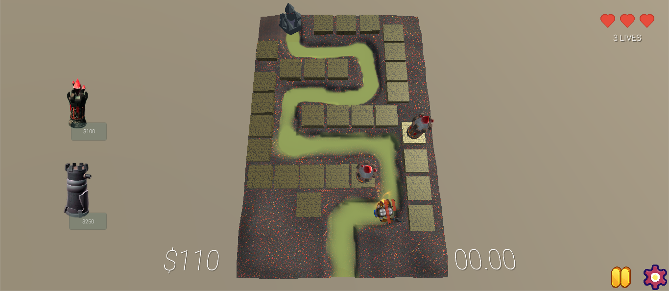

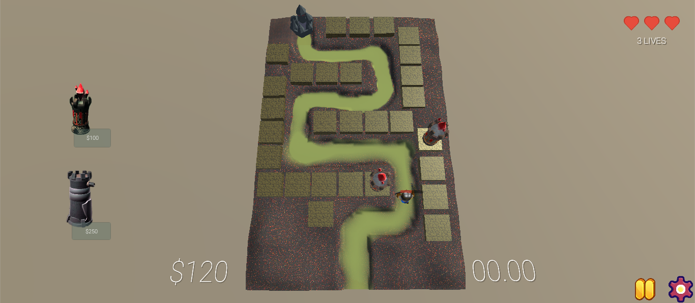

### Criteria: Enemy [Distinction]

* The enemy now can follow the path from start point to end point by automatically detecting the waypoints.
* Add the health bar for the enemies.
* Add animations for the enemy, so that they can be more exciting.
* Add the function to decrease the health bar of enemy when the bullet hitting on them.
* Add effect for the enemies when they die.

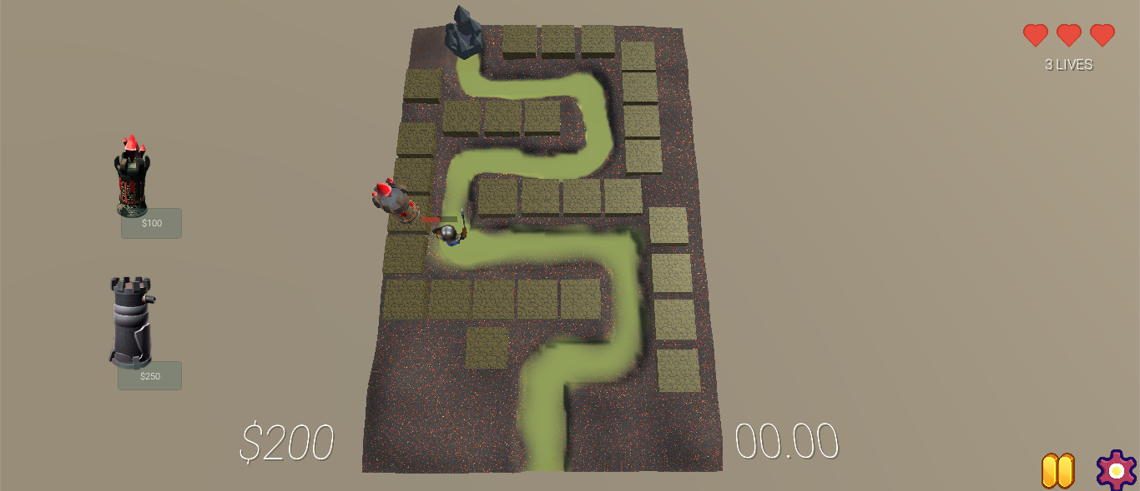

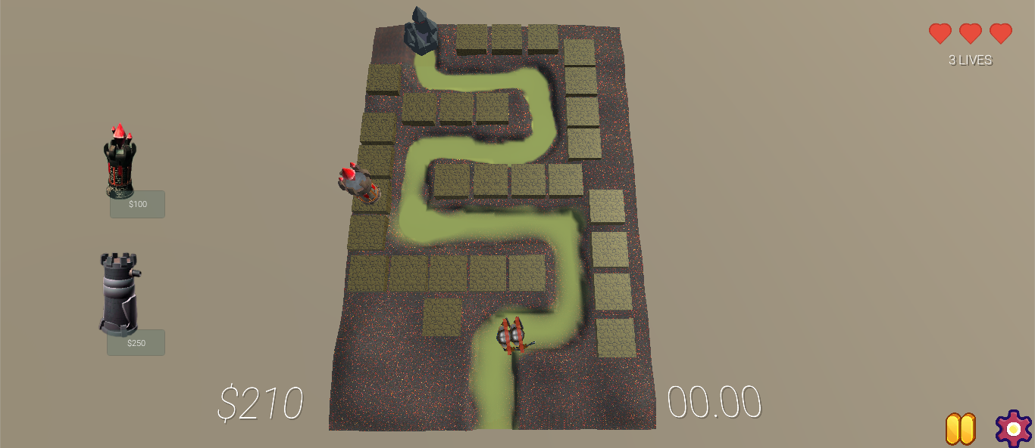

### Criteria: Level [Credit]

* Create a level UI for user to choose the level.
* Create the function to lock other levels that the player has not completed.
* Create the function that will unlock levels when the player reached.
* Add restart level function to reset all the level to the first position (level 1).

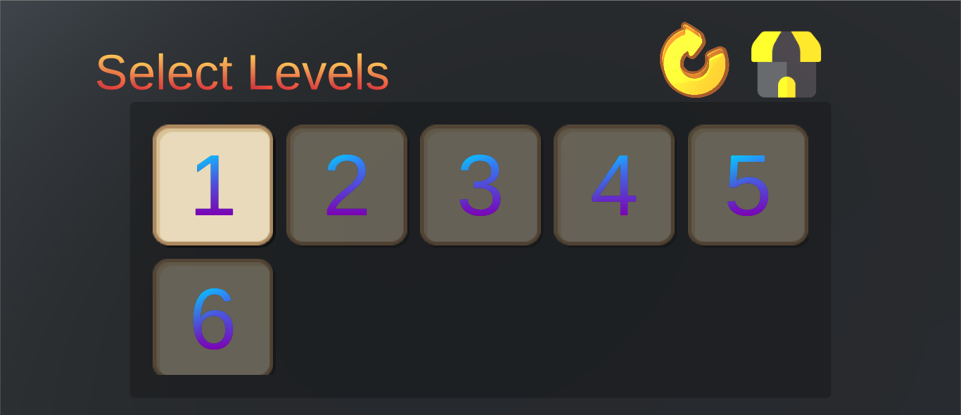

### Criteria: Setting Menu [Credit]

* Add the function to control the Master Volume of the whole game.
* Add the function to control the resolution of the game.
* When the setting menu is popped-up, all the motions of the game will be stop.

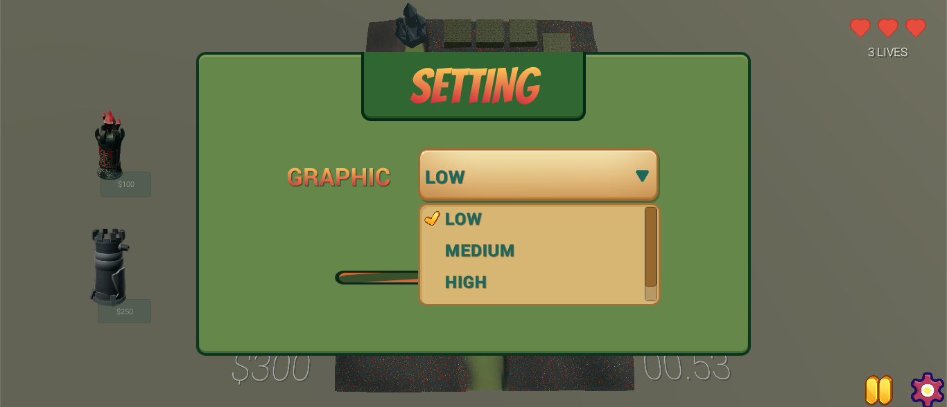

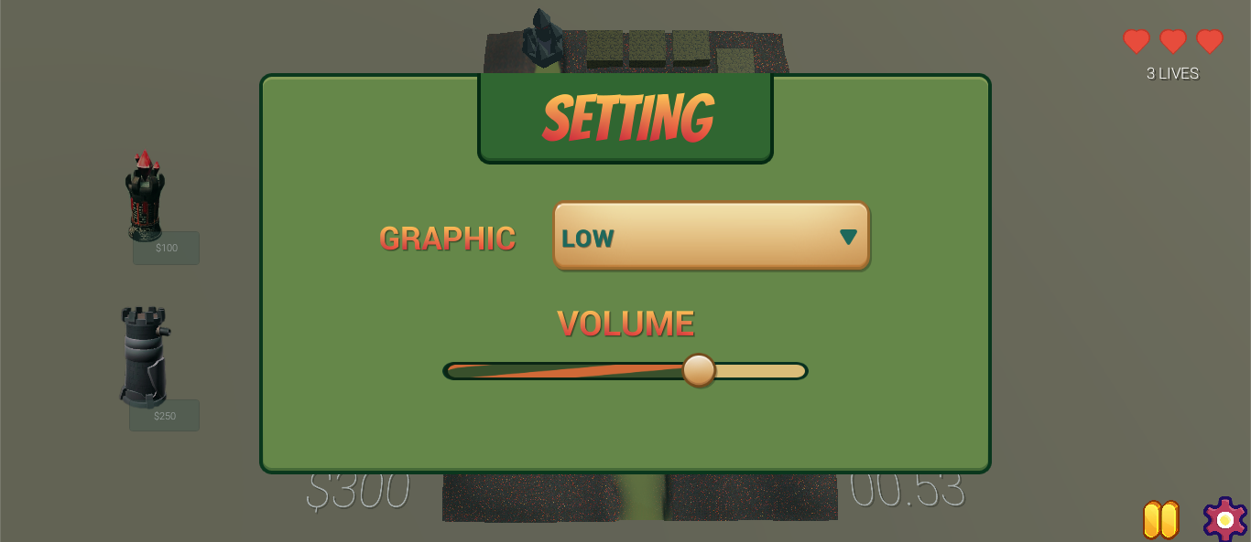

### Criteria: Lives [Credit]

* Set the start lives for the player (3 lives).
* The lives will be disappeared one-by-one when the enemy reached the End point.



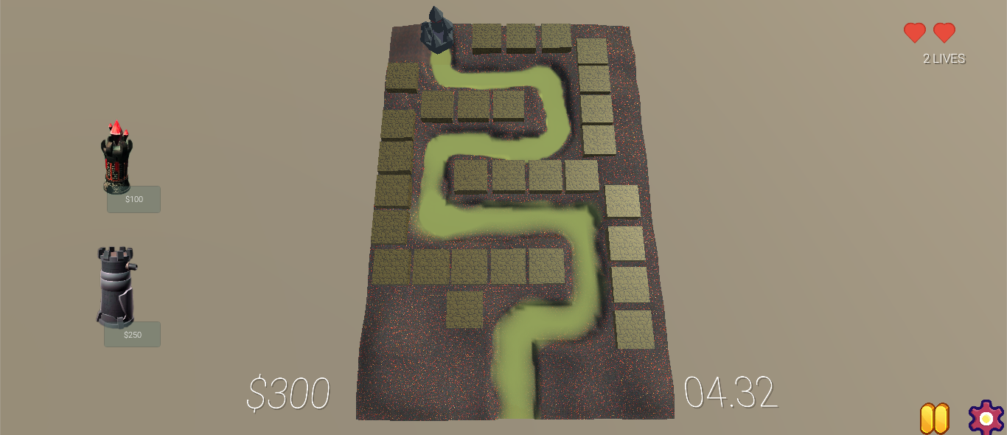

### Criteria: Sell and Upgrade [Distinction]

* The turret now can be upgraded to a new one or sold to earn money.
* Pop-up the panel for upgrade and sell when select the turret.
* Make effect for upgrade and sell the turret.
* When upgrade the turrets, it will create a new skin for the towers as well as the power for them.

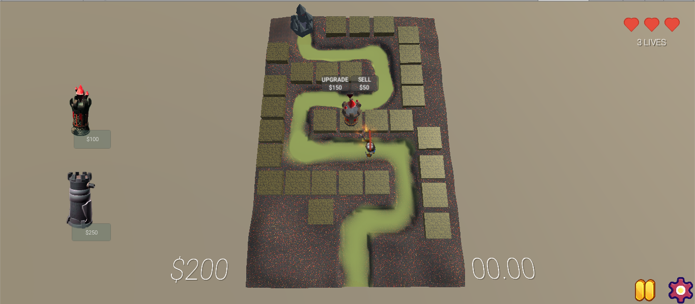

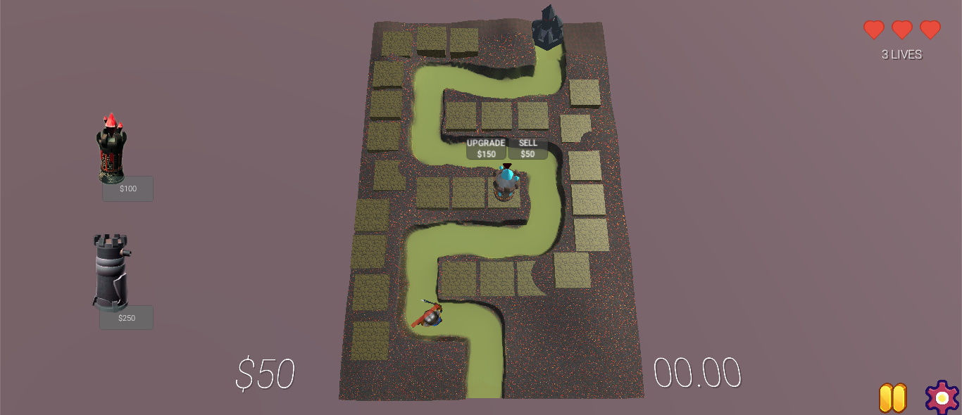

### Criteria: Game Over & Win Level [Credit]

* When the enemy hit the End point the Game Over Ui will be popped-up to show the number of rounds that player has finished and two buttons for player to control (Retry and Menu).
* The Win Level also pop-up when the player wins that level and player can tap Continue button to go next or Menu button to come back Level Select scene.

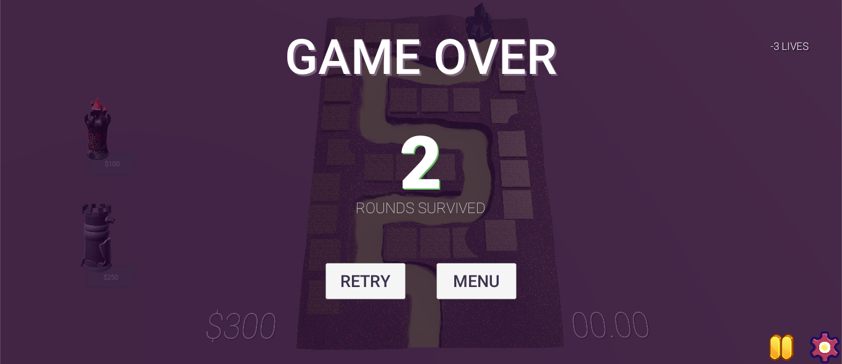

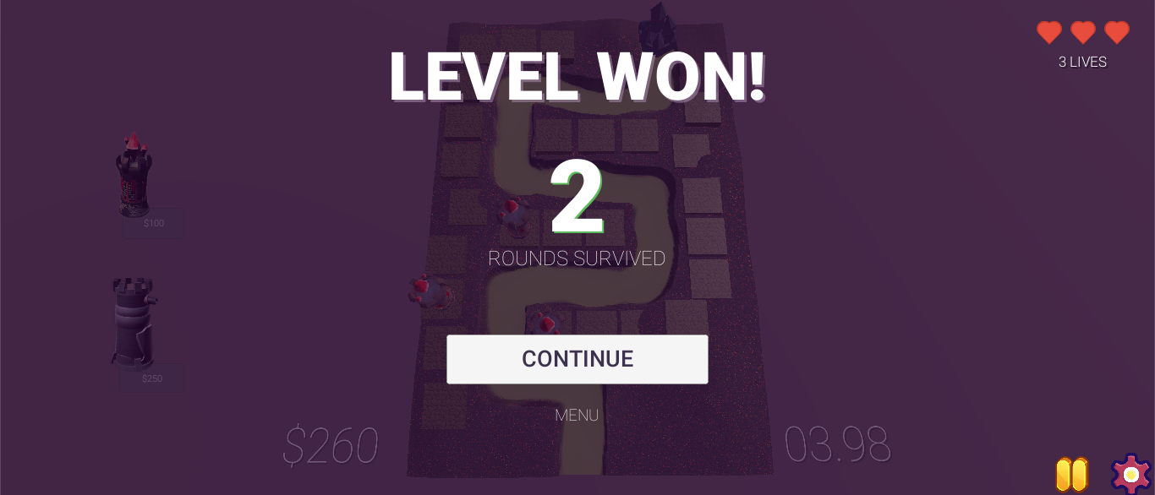

### Criteria: Run on Android Phone [Distinction]

* Our project app can be installed and run smoothly on the Android Phone via the file apk.

